

Use Case Specification: CSR eCL ETS Feed
For

eCoaching Log

Change History Log

Date | Version | Description | Author
11/13/2014 | 1.0 | Initial Document | Doug Stearns
11/20/2014 | 1.1 | P13659 – eCL ETS Data Feed  Updates based on review | Doug Stearns
12/01/2014 | 1.2 | P13891 – eCL Original Hierarchy  Inserted 3.23, 3.24, following items re-numbered  Removed 4.2.1, following items re-numbered  Modified Figure 1 | Doug Stearns
12/19/2014 | 1.3 | P14031 – eCL ETS Non-compliance Action Report  Initial updates | Doug Stearns
12/29/2014 | 1.4 | P14031 – eCL ETS Non-compliance Action Report  3.11 - Added Event Date for OAE  3.16 - Added text for OAE; Moved approver text to 4.3; Added fields to concatenate for OAE  3.21 - Added sub-reason for OAE  3.22 - Added value of Research Required for OAE  4.2x - Added for Event Date for OAS  4.4x - Added for Approver/Supervisor  4.5.1 - Added sub-reason for OAS  4.5.2 - Added value of Research Required for OAS and Opportunity for others  4.7.1 - Added employee job codes for OAE and OAS  7x - Revised to include exceptions  Figure 1 - Updated for OAE and OAS  note: some sections renumbered due to insertions | Doug Stearns

Table of Contents

1. Brief Description 6
2. Participating Actors 6
2.1 Primary 6
2.2 Secondary 6
3. Basic Flow of Events 7
3.1 System process executes at the scheduled time. 7
3.2 Input file accessed from appropriate folder. 7
3.3 eCoaching Log information is read from the input file. 7
3.4 Assign the coaching log Program from the Employee record Program. 7
3.5 Assign 221 (ETS) as the value of the coaching log source id. 7
3.6 Assign 6 (Pending Supervisor Review) as the value of the status id when the employee’s job code is WACS01, WACS02 or WACS03. 7
3.7 Assign the coaching log Site ID from the Employee record Site ID. 7
3.8 Assign the coaching log Employee LAN ID from the Employee record LAN ID when a match is found with the input Employee ID. 7
3.9 Assign the coaching log Employee ID from the input Employee ID. 7
3.10 Assign 999999 as the coaching log Submitter ID. 7
3.11 Assign the coaching log Event Date from the input Friday End Date (Time Period for OAE report code). 7
3.12 Assign 0 as the value for whether an Avoke ID is associated with the input record. 7
3.13 Assign 0 as the value for whether a NGD Activity ID is associated with the input record. 7
3.14 Assign 0 as the value for whether an UCID is associated with the input record. 7
3.15 Assign 0 as the value for whether a Verint ID is associated with the input record. 7
3.16 Assign the coaching log Description from the concatenation of the following information: 7
3.17 Assign the coaching log Submitted Date from the processing system date. 9
3.18 Assign 0 as the value of whether this coaching log is Acknowledged. 9
3.19 Assign 1 (CSR) as the value of the coaching log Module ID when the employee’s job code is WACS01, WACS02 or WACS03. 9
3.20 Assign ETS as the value of the coaching log Reason. 9
3.21 Assign as the value of coaching sub-reason based on the report code associated with the record when the employee’s job code is WACS01, WACS02 or WACS03. 9
3.22 Assign value of Opportunity with reason and sub-reason. Report code OAE receives a value of Research Required. 10
3.23 Assign value of employee’s supervisor. 10
3.24 Assign value of employee’s manager. 10
3.25 Submit the CSR ETS eCoaching Log 10
4. Alternative Flows 11
4.1 Pending Manager Review Status. [Step 3.6] 11
4.2 Event Date. [Step 3.11] 11
4.3 Supervisor Module. [Step 3.19] 11
4.4 Supervisor Log Description. [Step 3.16] 11
4.5 Supervisor Report Codes. [Step 3.21] 13
4.6 Employee Not Found. [Step 3.4] 14
4.7 Wrong Job Code. [Step 3.4] 14
5. Preconditions 15
5.1 ETS eCoaching Log input file exists and is available. 15
5.2 eCoaching Log database available. 15
5.3 eCoaching Log database populated with correct and current hierarchy information for CSR, Supervisors, Managers. 15
6. Postconditions 15
6.1 eCoaching Log submitted. 15
7. Assumptions and Dependencies 15
7.1 Input files are processed once a week on Tuesdays. Exceptions are: 15
8. Business Rules 15
8.1 none 15
9. Technical Requirements 15
9.1 none 15
10. Activity Diagrams 16

Table of Figures
Figure 1 – ETS Data Feed eCL Submission 11

Brief Description
Allow eCoaching Logs for call center Customer Service Representatives and Supervisors to be submitted through Electronic Timecard System report data feed.

Participating Actors

Primary

System process

Customer Service Representatives

Supervisors

Secondary

Managers

Sr. Managers

Basic Flow of Events

System process executes at the scheduled time.

Input file accessed from appropriate folder.

eCoaching Log information is read from the input file.

Assign the coaching log Program from the Employee record Program.

Assign 221 (ETS) as the value of the coaching log source id.

Assign 6 (Pending Supervisor Review) as the value of the status id when the employee’s job code is WACS01, WACS02 or WACS03.

Assign the coaching log Site ID from the Employee record Site ID.

Assign the coaching log Employee LAN ID from the Employee record LAN ID when a match is found with the input Employee ID.

Assign the coaching log Employee ID from the input Employee ID.

Assign 999999 as the coaching log Submitter ID.

Assign the coaching log Event Date from the input Friday End Date (Time Period for OAE report code).

Assign 0 as the value for whether an Avoke ID is associated with the input record.

Assign 0 as the value for whether a NGD Activity ID is associated with the input record.

Assign 0 as the value for whether an UCID is associated with the input record.

Assign 0 as the value for whether a Verint ID is associated with the input record.

Assign the coaching log Description from the concatenation of the following information:

The description will contain one of the following text based on the report code:
Report Code | Log Description Text
EOT | The exempt employee incorrectly recorded overtime hours. Exempt employees are expected to occasionally exceed the standard workweek (Saturday through Friday) as assigned tasks may demand. In most cases such work, which exceeds the standard workweek, is not eligible for additional pay and should be recorded as straight time. CCO exempt employees should not charge overtime without direction from CCO Communications.  The date, project and task numbers, time code, total and daily hours are below:
EA | The employee recorded incorrect Excused Absence hours. All paid leave (General Leave or floating Holiday time) must be exhausted before using Excused Absence 080984 | 3517. Excused Absence cannot be taken for full days of leave and you must have some worked hours recorded for the days this project | task code is used. Exempt employees absent for a full day must use LWOP 080984 | 9005.  The date, project and task numbers, time code, total and daily hours are below:
HOL | The non-exempt employee recorded incorrect hours on a holiday or recorded holiday hours on an incorrect day.  As a reminder, per HR-POL-203 Holidays, for employees with GSA administered benefits:  Holiday can only be recorded on the day it is observed.  To receive holiday pay, other paid hours must be recorded in the week in which a holiday is observed.  If an employee works on the observed holiday, holiday and time worked would be recorded.  If the observed holiday falls on an employee’s scheduled day-off, only holiday hours would be recorded.  Leave time cannot be recorded on a day in which a holiday is recorded.  Shift and bilingual premiums do not apply to holiday hours.  When an employee takes a fixed holiday off, the time must be charged in a whole-day increment to holiday, regardless of the total number of hours worked in the particular pay period.  The date, project and task numbers, time code, total and daily hours are below:
ITD | The employee recorded worked hours with a time code that is not valid in the CCO program. Please see your supervisor for a list of valid time codes used in the CCO.  The date, project and task numbers, time code, total and daily hours are below:
ITI | The employee recorded paid leave with an invalid time code. Paid leave is not eligible for shift or bilingual premium. All paid leave must be recorded with time code of 01 or *.  The date, project and task numbers, time code, total and daily hours are below:
FWH | The employee has entered worked hours in advance. The only circumstances in which worked hours should be entered in advance are:  When the employee’s Friday shift doesn’t start until after the stated deadline for them to sign their timecard or  When the employee is working off-site or traveling and will not have access to ETS.  If this employee doesn’t fall under one of these situations please coach them and have them remove the future worked hours from their timecard.  The date, project and task numbers, time code, total and daily hours are below:
OAE | The employee either did not sign his or her timecard by the Friday deadline for the period below, or it was signed with errors and rejected. Please review and take action as necessary.  The time period and employee name are below:

The following fields from the input record will be concatenated including the delimiter character and combined with the log description text (for report codes EOT, EA, HOL, ITD, ITI, FWH):
Project Number
Task Number
Task Name
Time Code
Employee Name
Hours
Sat
Sun
Mon
Tues
Wed
Thur
Fri

The following fields from the input record will be concatenated including the delimiter character and combined with the log description text (for report codes OAE):
Time Period
Employee Name

The following characters from the input record will be replaced with the corresponding string of characters:
& | &amp;
< | &lt;
> | &gt;
` | &#39;
" | &quot;
‘ | &lsquo;
’ | &rsquo;
’ | &prime;
? | &Prime;
“ | &ldquo;
” | &rdquo;
- | &ndash;

Assign the coaching log Submitted Date from the processing system date.

Assign 0 as the value of whether this coaching log is Acknowledged.

Assign 1 (CSR) as the value of the coaching log Module ID when the employee’s job code is WACS01, WACS02 or WACS03.

Assign ETS as the value of the coaching log Reason.

Assign as the value of coaching sub-reason based on the report code associated with the record when the employee’s job code is WACS01, WACS02 or WACS03.

The following are possible values:
Report Code | Sub-Reason
EA | Excused absence, paid leave
HOL | Holiday hours
ITD | Invalid time code – Direct
ITI | Invalid time code – Paid leave
FWH | Future hours
OAE | Outstanding Action (Employee)

Assign value of Opportunity with reason and sub-reason. Report code OAE receives a value of Research Required.

Assign value of employee’s supervisor.

Assign value of employee’s manager.

Submit the CSR ETS eCoaching Log

Alternative Flows

Pending Manager Review Status. [Step 3.6]

Assign 5 (Pending Manager Review) as the value of the status id when the employee’s job code is WACS40.

Continue with Step 3.7 above.

Event Date. [Step 3.11]

Assign the coaching log Event Date from the input Friday End Date (Time Period for OAS report code).

Continue with Step 3.12 above.

Supervisor Module. [Step 3.19]

Assign 2 (Supervisor) as the value of the coaching log Module ID when the employee’s job code is WACS40.

Continue with Step 3.20 above.

Supervisor Log Description. [Step 3.16]

Assign as the value of coaching log Description from the concatenation of the following information when the employee’s job code is WACS40.

The description will contain one of the following text based on the report code:
Report Code | Log Description Text
EOT | The exempt employee incorrectly recorded overtime hours. Exempt employees are expected to occasionally exceed the standard workweek (Saturday through Friday) as assigned tasks may demand. In most cases such work, which exceeds the standard workweek, is not eligible for additional pay and should be recorded as straight time. CCO exempt employees should not charge overtime without direction from CCO Communications.  The date, project and task numbers, time code, total and daily hours are below:
EA | The employee recorded incorrect Excused Absence hours. All paid leave (General Leave or floating Holiday time) must be exhausted before using Excused Absence 080984 | 3517. Excused Absence cannot be taken for full days of leave and you must have some worked hours recorded for the days this project | task code is used. Exempt employees absent for a full day must use LWOP 080984 | 9005.  The date, project and task numbers, time code, total and daily hours are below:
HOLA | A timecard was approved with incorrect hours recorded on a holiday or holiday hours recorded on an incorrect day.  As a reminder, per HR-POL-203 Holidays, for employees with GSA administered benefits:  Holiday can only be recorded on the day it is observed.  To receive holiday pay, other paid hours must be recorded in the week in which a holiday is observed.  If an employee works on the observed holiday, holiday and time worked would be recorded.  If the observed holiday falls on an employee’s scheduled day-off, only holiday hours would be recorded.  Leave time cannot be recorded on a day in which a holiday is recorded.  Shift and bilingual premiums do not apply to holiday hours.  When an employee takes a fixed holiday off, the time must be charged in a whole-day increment to holiday, regardless of the total number of hours worked in the particular pay period.  The date, project and task numbers, time code, total and daily hours are below:
ITDA | The employee approved a timecard with a time code that is not valid in the CCO program. The list of valid time codes can be found in the Common_CCO_Time_Codes document on CCO Knowledge Net under the timekeeping category.  The date, project and task numbers, time code, total and daily hours are below:
ITIA | The employee approved a timecard that had paid leave with and invalid time code. Paid leave is not eligible for shift or bilingual premium. All paid leave must be recorded with time code of 01 or *.  The date, project and task numbers, time code, total and daily hours are below:
FWHA | The employee has approved a timecard with worked hours entered in advance. The only circumstances in which worked hours should be entered in advance are:  When the employee’s Friday shift doesn’t start until after the stated deadline for them to approve timecards or  When the employee is working off-site or traveling and will not have access to ETS for approvals.  If this employee doesn’t fall under one of these situations please coach them and have them remove the future worked hours from their timecard.  The date, project and task numbers, time code, total and daily hours are below:
OAE | The employee either did not sign his or her timecard by the Friday deadline for the period below, or it was signed with errors and rejected. Please review and take action as necessary.  The time period and employee name are below:
OAS | The supervisor did not approve or reject the timecard below by the Friday deadline. Please review and take action as necessary.  The time period and employee name are below:

The following fields from the input record will be concatenated including the delimiter character and combined with the log description text (for report codes EOT, EA, HOLA, ITDA, ITIA, FWHA):
Project Number
Task Number
Task Name
Time Code
Employee Name
Hours
Sat
Sun
Mon
Tues
Wed
Thur
Fri

The following fields from the input record will be concatenated including the delimiter character and combined with the log description text (for report codes OAE, OAS):
Time Period
Employee Name
Associated Person (OAS only)

The following characters from the input record will be replaced with the corresponding string of characters:
& | &amp;
< | &lt;
> | &gt;
` | &#39;
" | &quot;
‘ | &lsquo;
’ | &rsquo;
’ | &prime;
? | &Prime;
“ | &ldquo;
” | &rdquo;
- | &ndash;

Continue with 3.17 above.

Supervisor Report Codes. [Step 3.21]

Assign as the value of coaching sub-reason based on the report code associated with the record when the employee’s job code is WACS40.

The following are possible values:
Report Code | Sub-Reason
EOT | Exempt OT hrs
EA | Excused absence, paid leave
HOLA | Holiday hours (Approver)
ITDA | Invalid time code – Direct (Approver)
ITIA | Invalid time code – Paid leave (Approver)
FWHA | Future hours (Approver)
OAE | Outstanding Action (Employee)
OAS | Outstanding Action (Supervisor)

Assign value of Opportunity with the reason and sub-reason. Report code OAS receives a value of Research Required.

Continue with 3.23 above.

Employee Not Found. [Step 3.4]

Do not create an eCoaching log if the employee ID from the report file is not found.

Continue with next report record.

Wrong Job Code. [Step 3.4]

Do not create an eCoaching log if the employee’s job code does not correspond to the report code.

The following are possible values:
Job Code | Report Code | Report
WACS01, WACS02, WACS03, WACS40 | EOT | Exempt OT hrs
WACS01, WACS02, WACS03, WACS40 | EA | Excused absence, paid leave
WACS01, WACS02, WACS03 | HOL | Holiday hours
WACS40 | HOLA | Holiday hours (Approver)
WACS01, WACS02, WACS03 | ITD | Invalid time code – Direct
WACS40 | ITDA | Invalid time code – Direct (Approver)
WACS01, WACS02, WACS03 | ITI | Invalid time code – Paid leave
WACS40 | ITIA | Invalid time code – Paid leave (Approver)
WACS01, WACS02, WACS03 | FWH | Future hours
WACS40 | FWHA | Future hours (Approver)
WACS01, WACS02, WACS03, WACS40 | OAE | Outstanding Action (Employee)
WACS40 | OAS | Outstanding Action (Supervisor)

Continue with next report record.

Preconditions

ETS eCoaching Log input file exists and is available.

eCoaching Log database available.

eCoaching Log database populated with correct and current hierarchy information for CSR, Supervisors, Managers.

Postconditions

eCoaching Log submitted.

Assumptions and Dependencies

Input files are processed once a week on Tuesdays. Exceptions are:

Future Hours report which is also run on Wednesdays

Outstanding Action reports which are also run on Thursdays

Business Rules

none

Technical Requirements

none

Activity Diagrams
Below is the activity diagram for the use case that provides a visual depiction of the flow of events.

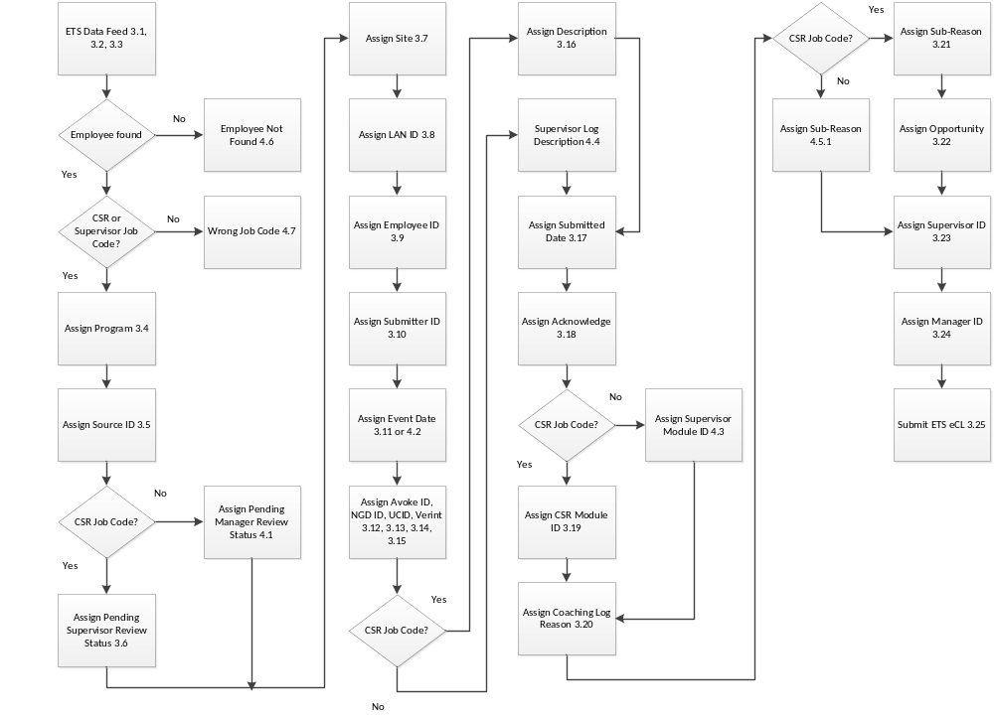

Figure 1 – ETS Data Feed eCL Submission

